

Faculty of Engineering and Technology

Department of Electrical and Computer Engineering

Computer Networks (ENCS3320)

**Project 2 Report**

**Prepared by:**

* **Abdallah Abualwalaya**
  + SID : 1201240
  + Instructor : Dr. Mohammad Jubran
  + Section : 3
* **Ali Kok**
  + SID : 1220375
  + Instructor : Dr. Mohammad Jubran
  + Section: 3
* **Qasem** 
  + SID : 1230486
  + Instructor : Dr. Mohammad Jubran
  + Section: 3

Contents

**Abstract:** 4

**Theory and Procedure:** 5

Networking Fundamentals 5

IP Addressing and Subnetting 5

Routing and Routing Protocol 5

Network Devices and Their Configuration 6

Subnet Table 6

**Theory and Procedure:** 7

**Conclusion:** 27

**Table of Figures**

**Figure 1: Static IP configuration for Printer_ECE** 8

**Figure 2: Static IP configuration for Printer_CS.** 9

**Figure 3: Dynamic IP configuration for an ECE network end device.** 10

**Figure 4: Dynamic IP configuration for an CS network end device.** 11

**Figure 5: Static IP configuration for an R0_IT router port.** 12

**Figure 6: Static IP configuration for an R1_IT router port.** 13

**Figure 7: Successful Ping results within the Faculty of Engineering and Technology network.** 14

**Figure 8: IP configuration of DHCP servers.** 15

**Figure 9: IP configuration of DNS servers.** 16

**Figure 10: IP configuration of Email servers.** 17

**Figure 11: IP configuration of Web servers.** 18

**Figure 12: Email service with the user setup on the mail.it.birzeit.edu.** 19

**Figure 13: DNS service with the RRs on the dns.it.birzeit.edu.** 20

**Figure 14: DHCP service with the pools on the dhcp.it.birzeit.edu.** 21

**Figure 15: Static IP configuration for PC_Home.** 22

**Figure 16: Dynamic IP configuration for a home network end device.** 23

**Figure 17: Static IP configuration of the R_Home router port.** 24

**Figure 18: Successful Ping results between home network devices.** 25

**Figure 19: Wireless network configuration for ENCS3320Home.** 26

**Figure 20: Successful access to www.it.birzeit.edu from a home network end device.** 27

# **Abstract:**

This report details a network topology simulation conducted in Cisco's Packet Tracer, aiming to apply fundamental networking principles. The project involved designing a segmented network with routers, switches, and servers, emphasizing IP subnetting and routing protocols like OSPF. Key tasks included configuring network devices, establishing connectivity, and integrating DNS, HTTP, and email services. The successful implementation demonstrated practical networking skills, efficient IP address utilization, and effective communication across the network. This exercise provided valuable insights into network setup and management, reflecting the application of theoretical concepts in a simulated environment.

# **Theory and Procedure:**

## Networking Fundamentals

This project centered on the basics of computer networking, focusing on connecting devices for data sharing. We examined how different network topologies affect data flow and network stability. These concepts were key in our Packet Tracer simulation, guiding us to build an efficient and functional network model.

## IP Addressing and Subnetting

In our project, IP addressing and subnetting were pivotal for efficient network organization and management. We utilized IP addresses to uniquely identify each device, facilitating accurate data routing. Subnetting helped us divide the larger network into smaller, manageable segments, enhancing network performance and security. This approach allowed for optimal use of IP addresses and contributed to a more structured and efficient network in our Packet Tracer simulation.

## Routing and Routing Protocol

Our project utilized routing protocols, specifically OSPF , to direct data efficiently across the network. These protocols played a crucial role in determining the best paths for data transmission, ensuring reliable and effective communication between different network segments in our Packet Tracer setup.

## Network Devices and Their Configuration

Our project incorporated essential network devices such as routers, switches, and servers, each configured to fulfill specific roles within our Packet Tracer simulation. Proper configuration of these devices was crucial to ensure network reliability and performance, demonstrating the practical impact of device settings on the overall network functionality.

## Subnet Table

|  |  |  |  |  |  |
| --- | --- | --- | --- | --- | --- |
| Subnet | Subnet Mask "Using the slash notation" | Network IP | Broadcast IP | First IP | Last IP |
| ECE | 255.255.255.128 → 180.75.72.0/25 | 180.75.72.0 | 180.75.72.127 | 180.75.72.1 | 180.75.72.126 |
| CS | 255.255.255.192 → 180.75.72.128/26 | 180.75.72.128 | 180.75.72.191 | 180.75.72.129 | 180.75.72.190 |
| Servers | 255.255.255.224 → 180.75.72.192/27 | 180.75.72.192 | 180.75.72.223 | 180.75.72.193 | 180.75.72.222 |
| Backbone | 255.255.255.252 → 180.75.72.224/30 | 180.75.72.224 | 180.75.72.227 | 180.75.72.225 | 180.75.72.226 |

# **Theory and Procedure:**

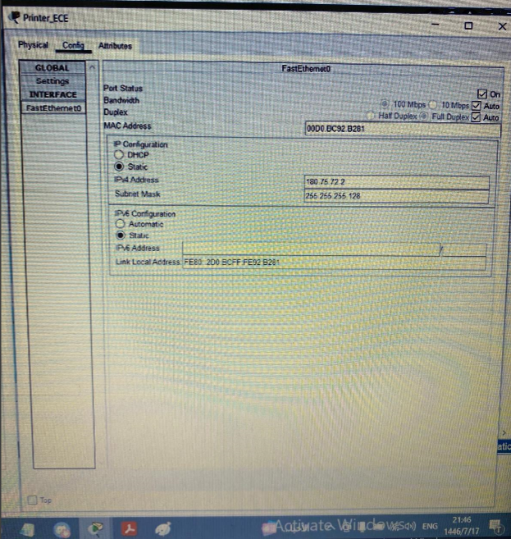

**Figure 1: Static IP configuration for Printer_ECE**

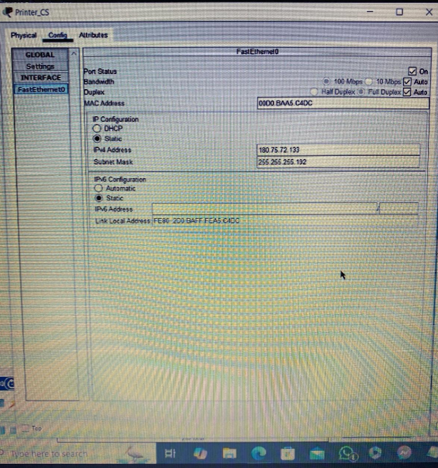

**Figure 2: Static IP configuration for Printer_CS.**

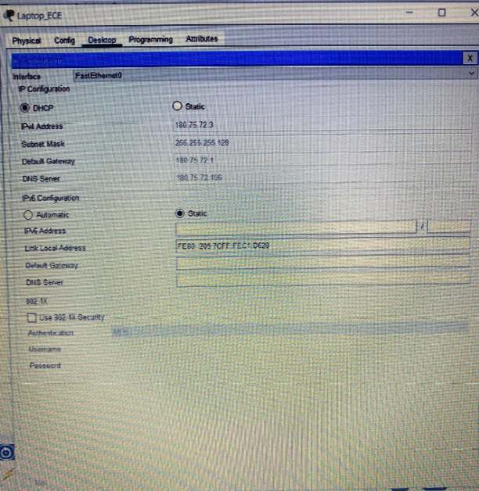

**Figure 3: Dynamic IP configuration for an ECE network end device.**

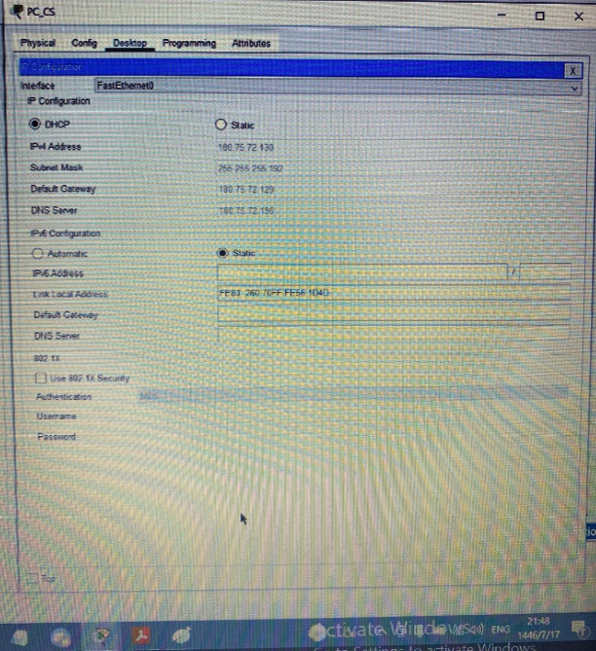

**Figure 4: Dynamic IP configuration for an CS network end device.**

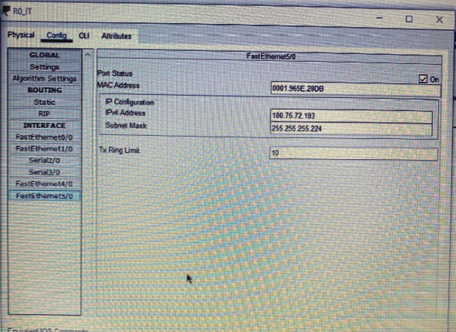

**Figure 5: Static IP configuration for an R0_IT router port.**

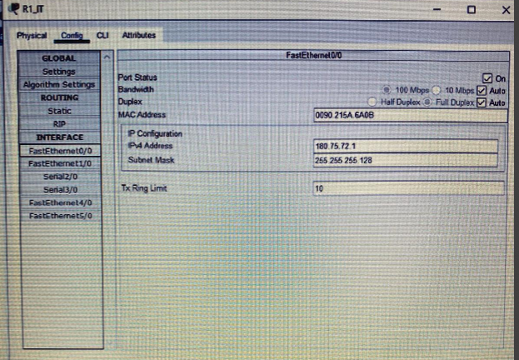

**Figure 6: Static IP configuration for an R1_IT router port.**

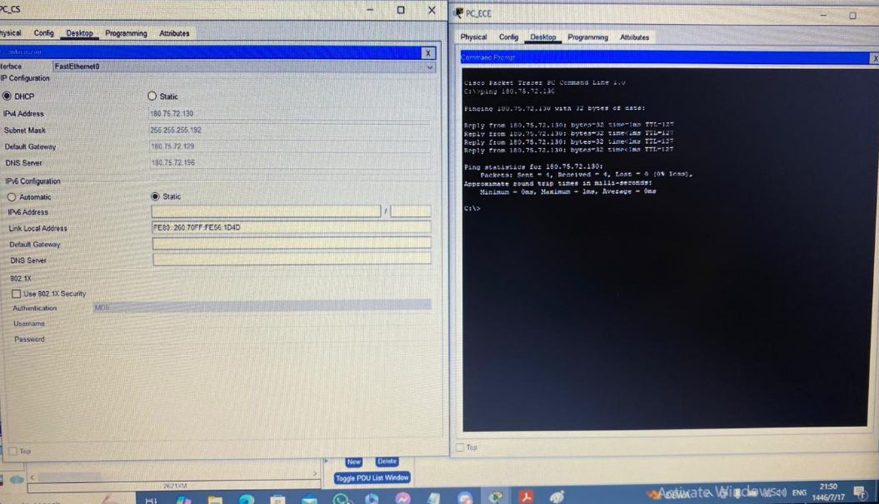

**Figure 7: Successful Ping results within the Faculty of Engineering and Technology network.**

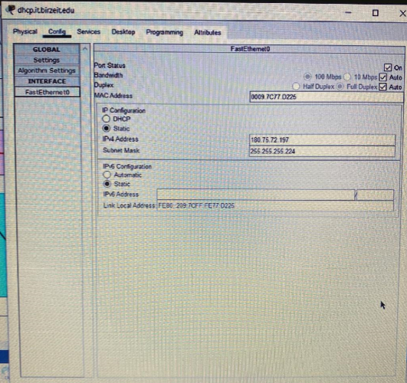

**Figure 8: IP configuration of DHCP servers.**

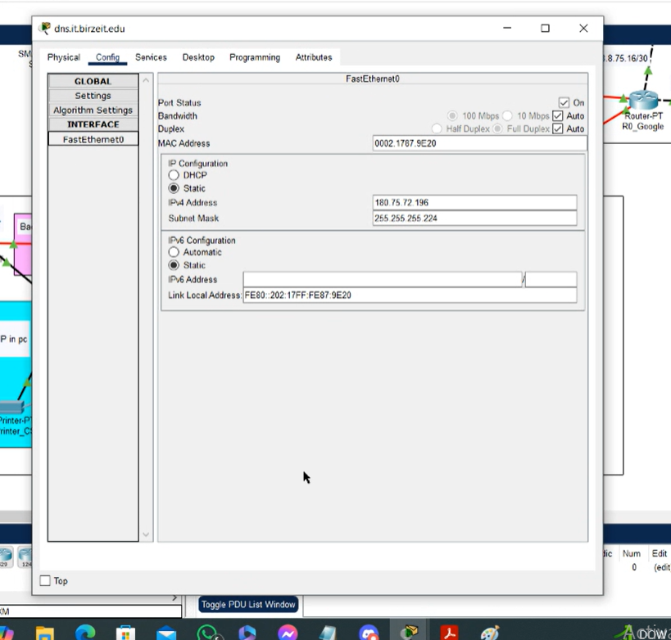

**Figure 9: IP configuration of DNS servers.**

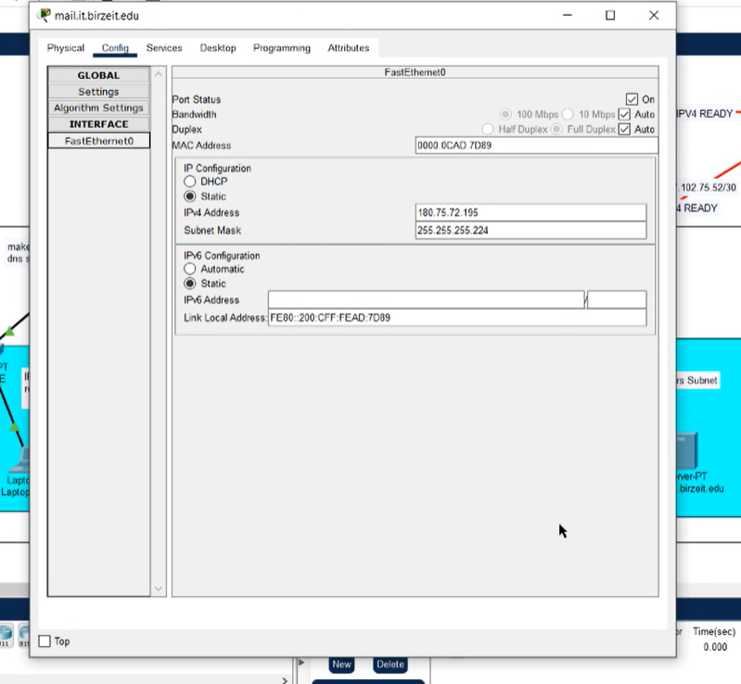

**Figure 10: IP configuration of Email servers.**

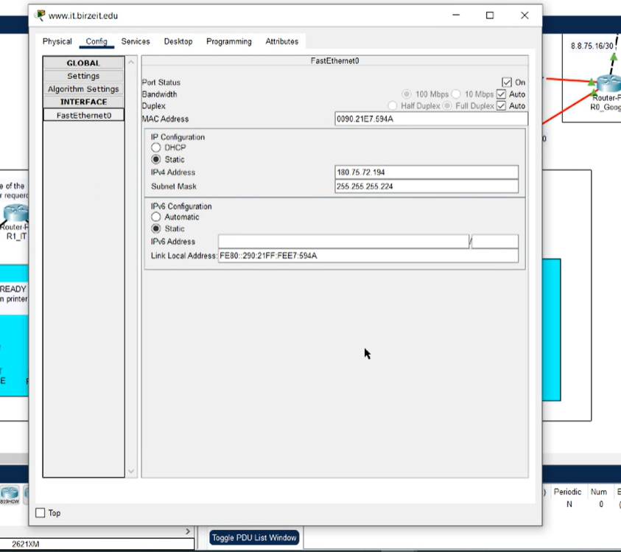

**Figure 11: IP configuration of Web servers.**

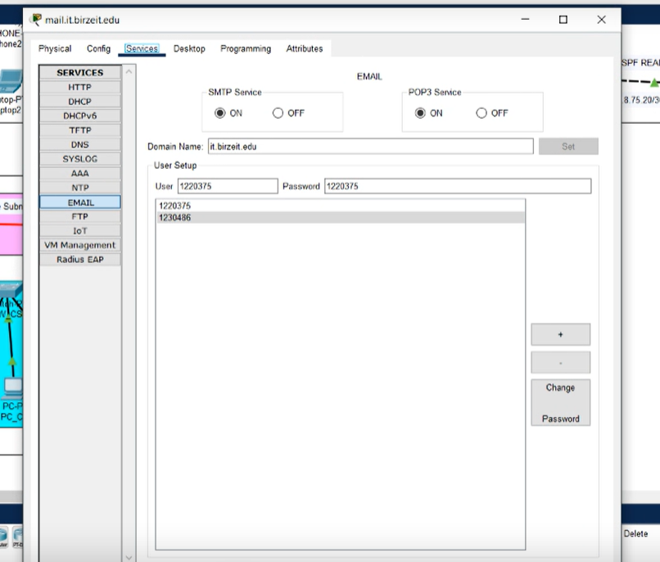

**Figure 12: Email service with the user setup on the mail.it.birzeit.edu.**

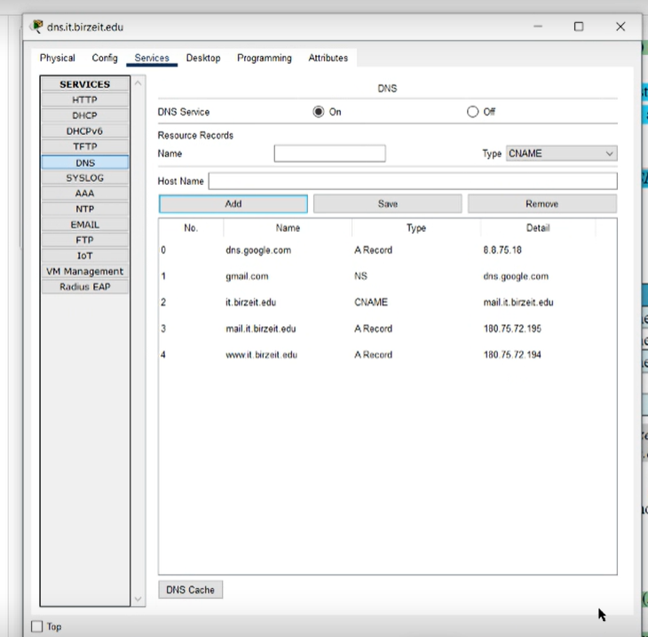

**Figure 13: DNS service with the RRs on the dns.it.birzeit.edu.**

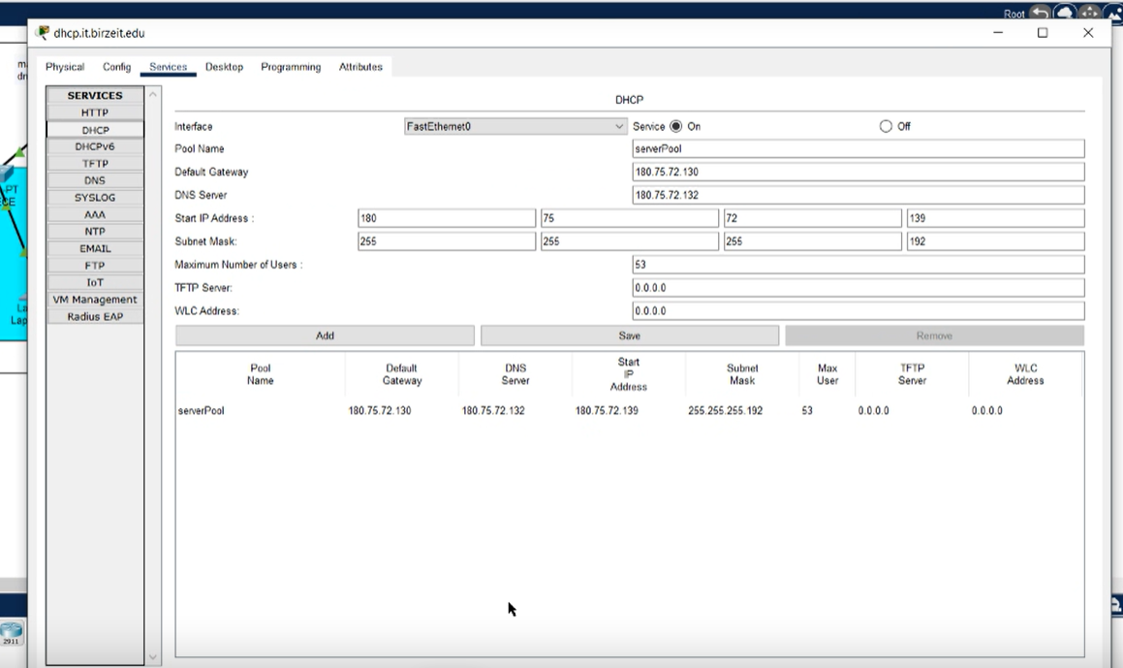

**Figure 14: DHCP service with the pools on the dhcp.it.birzeit.edu.**

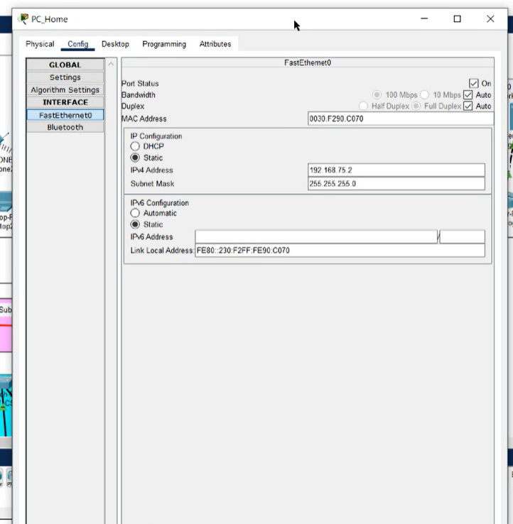

**Figure 15: Static IP configuration for PC_Home.**

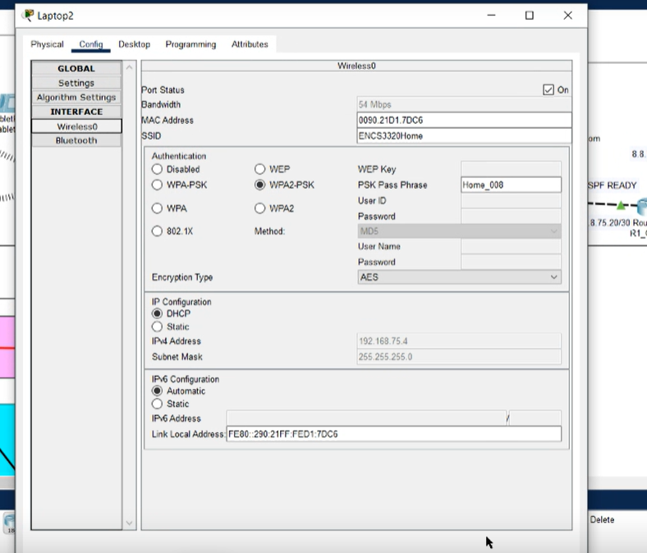

**Figure 16: Dynamic IP configuration for a home network end device.**

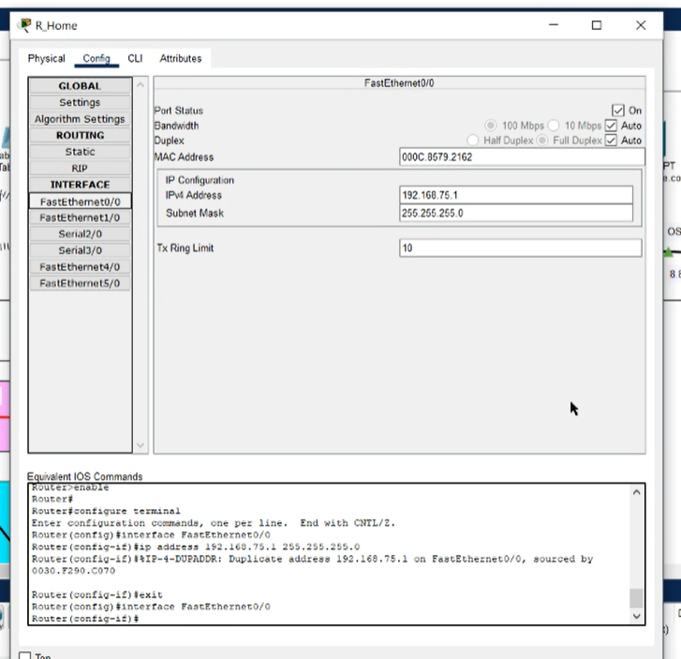

**Figure 17: Static IP configuration of the R_Home router port.**

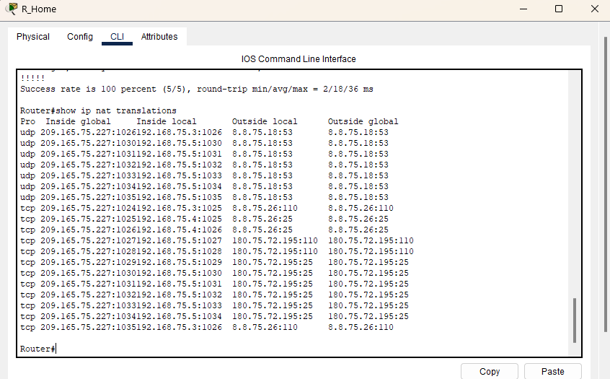

**Figure 18 NAT Table of R_Home Router**

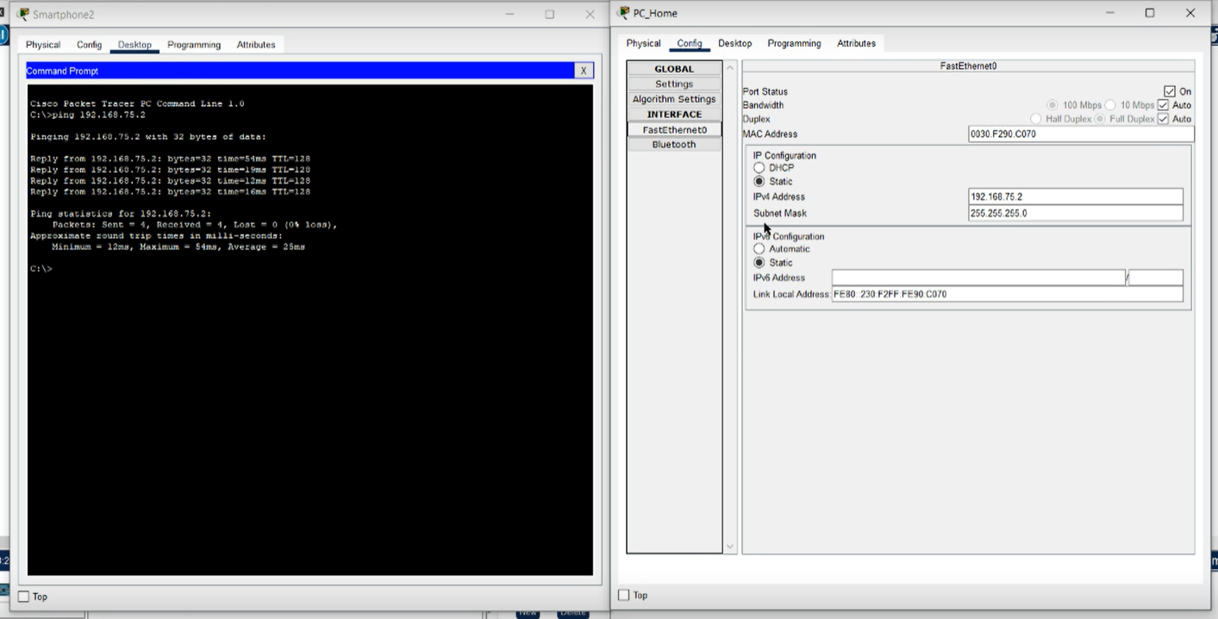

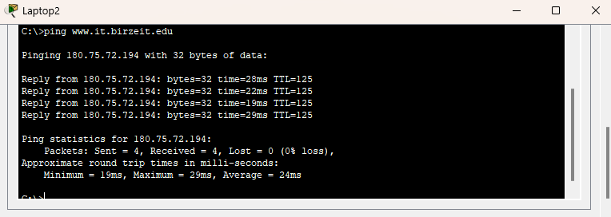

**Figure 19: Successful Ping results between home network devices.**

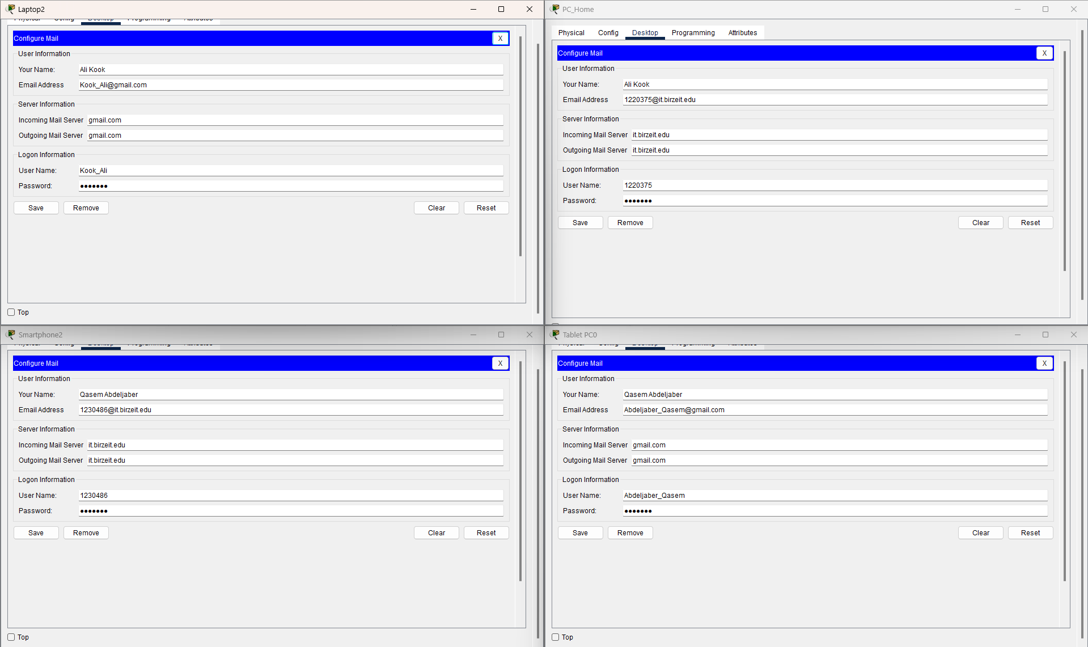

**Figure 20 Email Client Configuration for gmail and it.birzeit.edu accounts**

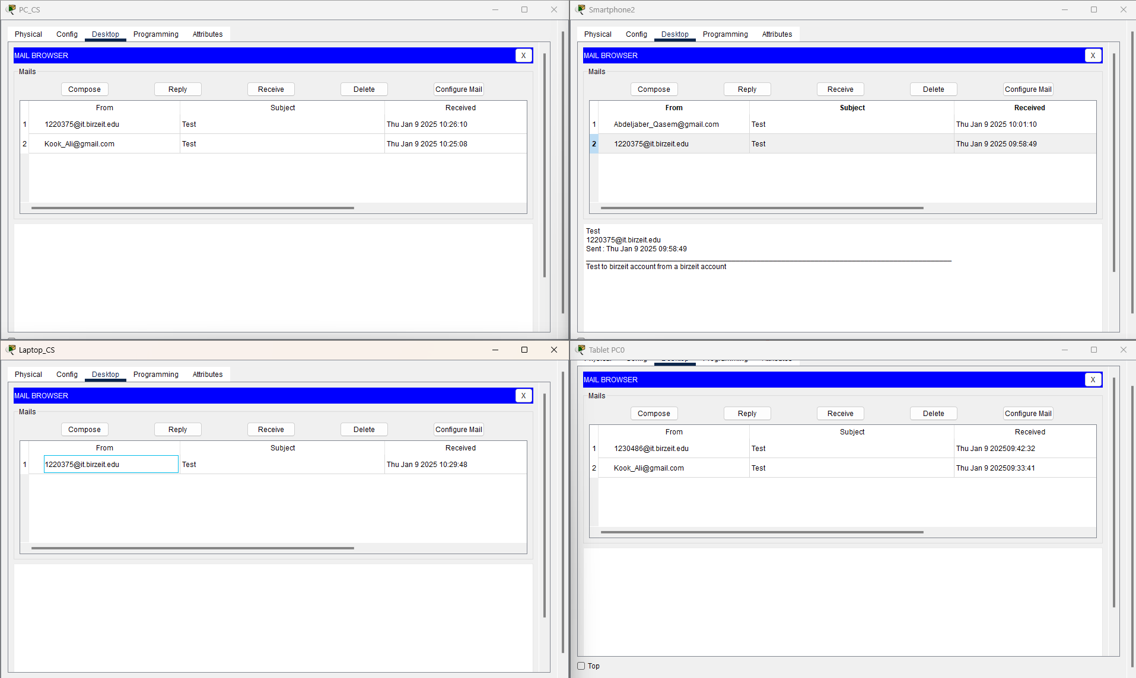

**Figure 21 Successful sending and receiving of Emails**

The email was successfully sent from the Home-ISP network and retrieved on both the Home-ISP and Faculty of Engineering and Technology networks. This confirms that the mail servers, DNS configurations, and routing between the networks are functioning correctly. No issues were encountered during the process.

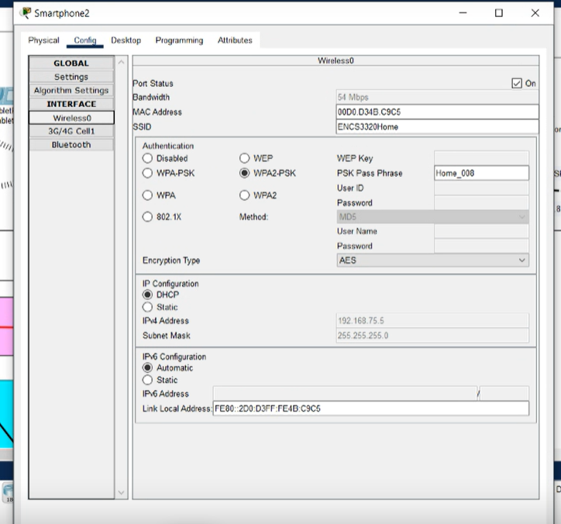

**Figure 22: Wireless network configuration for ENCS3320Home.**

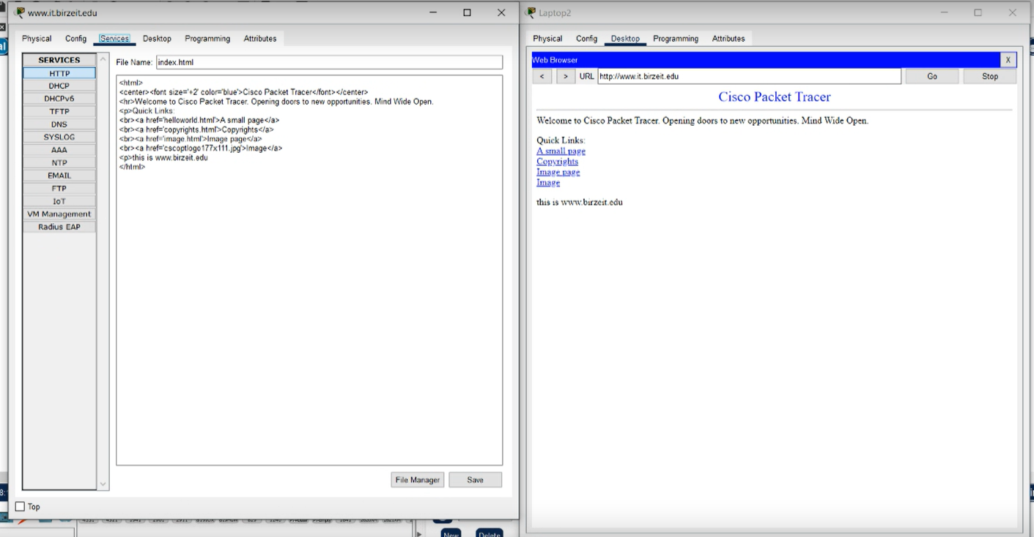

**Figure 23: Successful access to www.it.birzeit.edu from a home network end device.**

# **Conclusion:**

In this project, we conducted network emulation using Packet Tracer, gaining valuable insights into essential network components. Our journey began with configuring routers, a critical initial step in network setup. We delved into the physical aspects of routers and their components. Determining the required number of subnets and assigning unique IP addresses based on student IDs was our next task. We also explored server types, such as DNS, Email, and HTTP, configuring them accordingly. Finally, we observed packet movement between PCs and successfully addressed any troubleshooting challenges.